Dangerous Goods by Air Transport
What are dangerous goods?
Dangerous goods are articles or substances that are capable of posing a significant risk to health, safety or property when transported by air and which are classified/regulated in the IATA Dangerous Goods Regulations (D.G.R.).
For example, paint, dry ice, batteries, automobiles, etc., are regulated as dangerous goods when transported by air.
Offering Dangerous Goods for Air Transport
For air transport safety, a shipper who knows best about his/her articles or substances must ensure that the articles or substances must be properly identified, classified, packed, marked, labeled and documented in accordance with IATA D.G.R.
Special Handling of Dangerous Goods by Cargo Network
All acceptable dangerous goods are handled with the utmost of special care by our experienced cargo staff, whose members are highly knowledgeable and trained in accordance with IATA D.G.R.

Marking
For the purpose of safe transport and emergency handling, markings are required on the outside of packages.
Essential markings
- Proper Shipping Name : Standard names used in the transport of dangerous goods
- UN or ID Number : Specific number for dangerous good
- Full name and address of shipper and consignee
Labelling
- All labels, hazard labels and handling labels must be affixed to packages of dangerous goods to ensure proper handling.

Shipper’s Declaration for Dangerous Goods
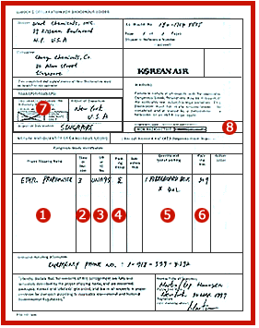 | Proper Shipping Name  - Standard names used in the transport of dangerous goods  Class or Division  - Type of hazard  UN or ID No.  - Specific number for dangerous good  Packing Group : The applicable degree of danger within the class  - Subsidiary Risk  - Subsidiary Risk (Main risk expressed Class or Division)  Quantity and Type of Packaging  - Packaging, quality, quantity, number, etc.  Packing Instruction  - Guidance of packing  Cargo Air Craft Only or Not?  Radio Active Material or Not?

Dangerous Goods by Sea Transport
What are dangerous goods?
Dangerous goods are articles or substances that are capable of posing a significant risk to health, safety or property when transported by sea and which are classified/regulated in the IMO, Interantional Maritime Dangerous Goods Code (IMDG CODE).
For example, paint, batteries, Gases, etc., are regulated as dangerous goods when transported by sea.
Offering Dangerous Goods for Sea Transport
For air transport safety, a shipper who knows best about his/her articles or substances must ensure that the articles or substances must be properly identified, classified, packed, marked, labeled and documented in accordance with IATA D.G.R.
Special Handling Dangerous Goods by Cargo Network
All acceptable dangerous goods are handled with the utmost of special care by our experienced cargo staff, whose members are highly knowledgeable and trained in accordance with IMDG CODE.

Marking
For the purpose of safe transport and emergency handling, markings are required on the outside of packages.
Essential markings
- Proper Shipping Name : Standard names used in the transport of dangerous goods
- UN or ID Number : Specific number for dangerous good
- Full name and address of shipper and consignee
Labelling
- All labels, hazard labels and handling labels must be affixed to packages of dangerous goods to ensure proper handling.

Inspection Charge

 | Dangerous Goods by Air Transport | Dangerous Goods by Sea Transport
The Inspection Authorities | Korea Merchandise Testing  and Research Institute | Korea Maritime Dangerous Goods Inspection Center (KOMDIC)
COST | Inspection Charge | Inspection Charge
COST | KRW 80,000 | CONTAINER  KRW 70,000 - 20feet  KRW 84,000 - 40feet  KRW 80,000 - BULK
COST | ** Excluding DG Handling Charge & Packing Charge

Label & Placard

Class1-Explosives

Division 1.1 Division 1.2 Division 1.3
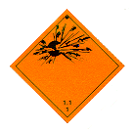
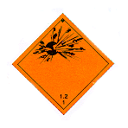

Division 1.4 Division 1.5 Division 1.6
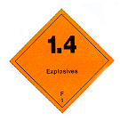
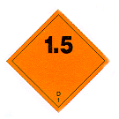
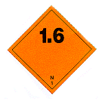

Class2 - Compressed Gases DIVISION 2.1, 2.2, 2.3
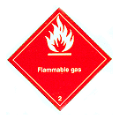
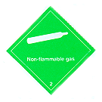
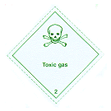

Class3 - Flammable Liquids
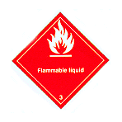

Class4 - Other Flammable Hazard DIVISION 4.1, 4.2, 4.3
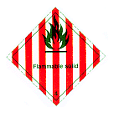
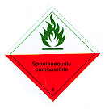


Class5-Oxigen Source DIVISION 5.1, 5.2
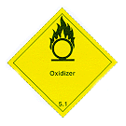
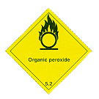

Class6 - Subtances affecting Healt Division 6.1, 6.2
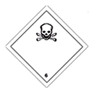
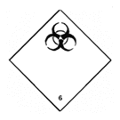

Class7 - Radioactive Materials WHITE, YELLOW II, YELLOW III
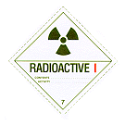
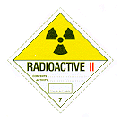
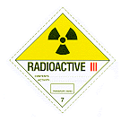

Class8 - Corrosive Materials Class9 -Miscellaneous Hazards
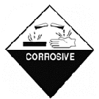



Magnetized Materia Cargo Aircraft Only Cryogenic Liquid
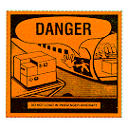
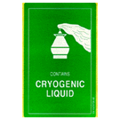



This Way Up

